COMP 3123 Lab Exercise 2 Screenshots
Exercise 1:
code
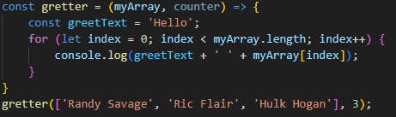
output
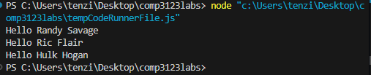

Exercise 2:
code
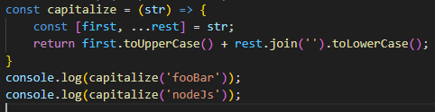
Output
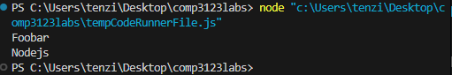

Exercise 3:
Code
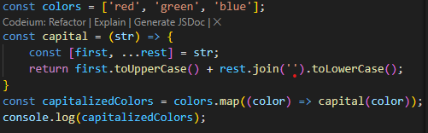
Output
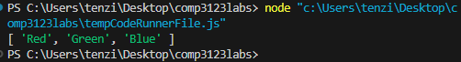

Exercise 4
Code
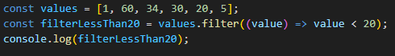
Output
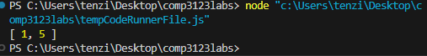

Exercise 5
Code
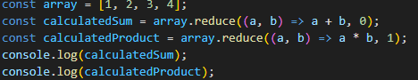
Output
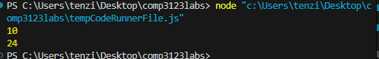

Exercise 6
Code
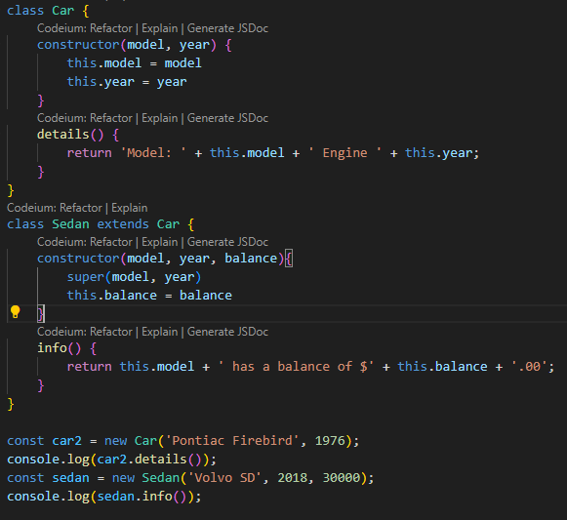
Output
